OTC

1. Lookup applicant: 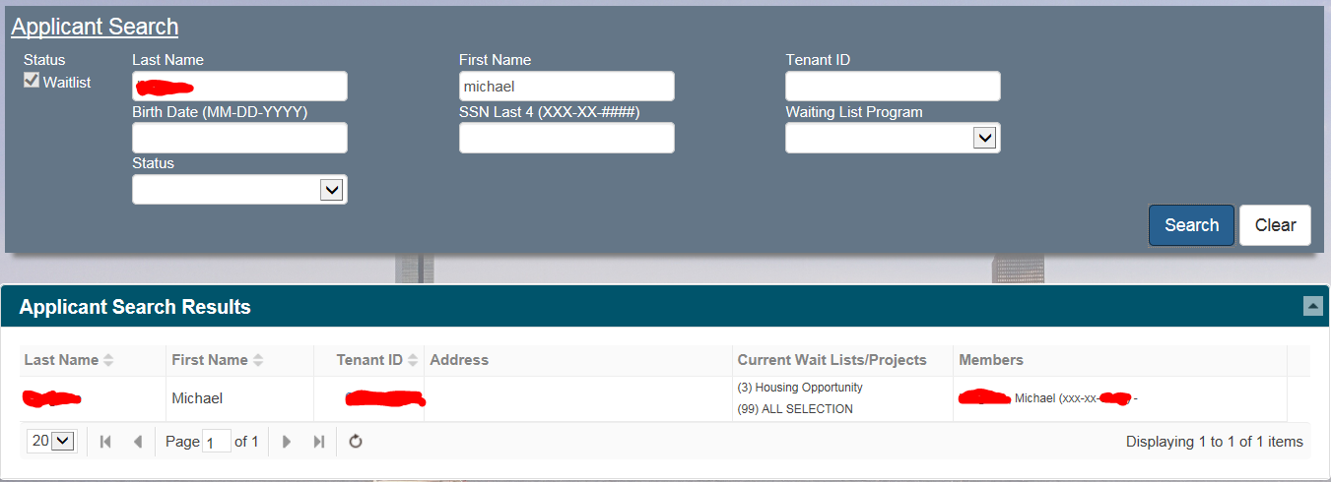
2. Click on “Member” tile to ensure family composition is accurate with application.
3. Click on “Income” tile to ensure income information is accurate with the calculation sheet used when the applicant came in for the eligibility briefing.
4. Click on the “Actions” drop-down menu then select “Perform Action”: 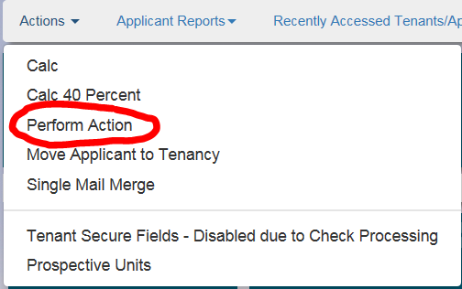
5. Under “Select Wait List to Perform Action” select the appropriate program. **An applicant may have multiple entries so be sure to select the correct program.** Once a program is selected then the “Perform Action” sub-menu will generate: 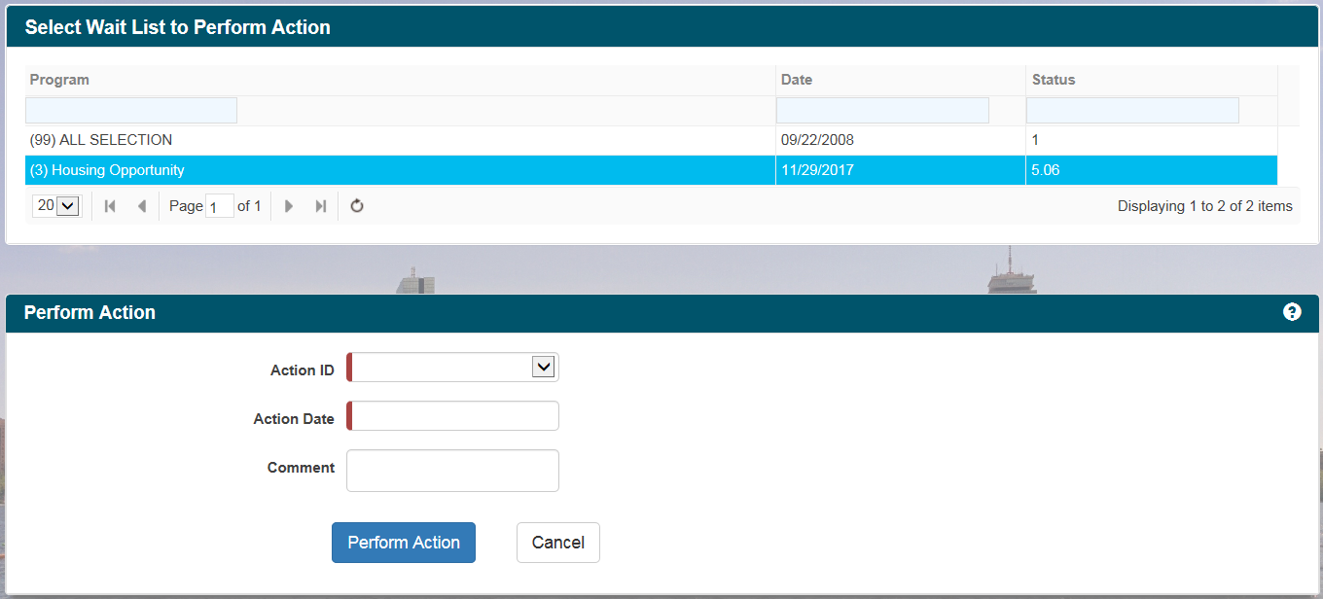
6. On the “Action ID” drop-down menu, select status “6.0000 ON THE CLOCK ACTION”. The “Action Date” input field must reflect the date the voucher was issued. **Do not use the date you’re running the action as this will create inconsistent dates.** The “Comment” field is optional but it’s best to leave it blank. “Program Rep’s Name” and “Title” can also be left blank as this action does not generate any letters: 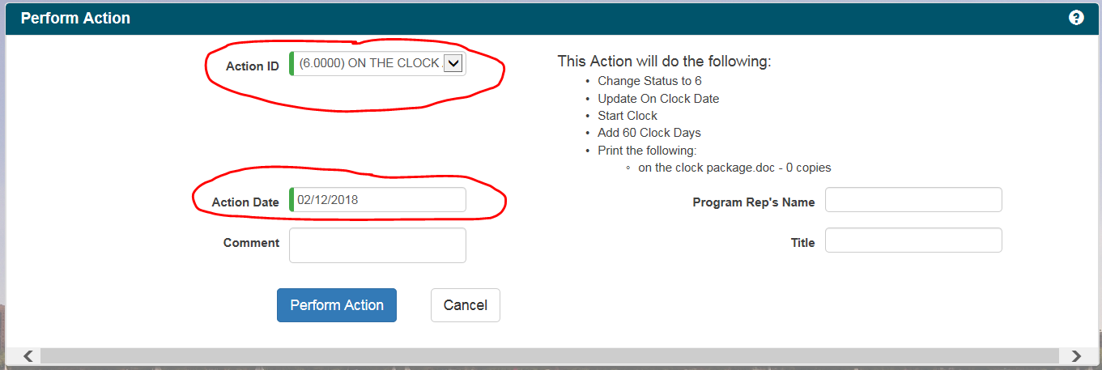
7. Click on the “Perform Action” button when ready. Tracker will then generate the on the clock dates including the date the voucher was issued as well as the initial expiration date.
8. Click on the “Actions” drop-down menu then select “Calc”: 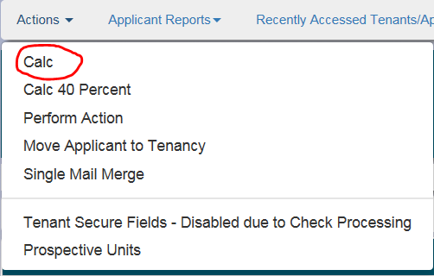
9. On the “Calc Information” area, select “(10) Issuance of Voucher” in the “Calc Type” drop-down menu. The “Effective Date” field will be the date the voucher was issued. Disregard all other areas as nothing is being calculated with this calc type.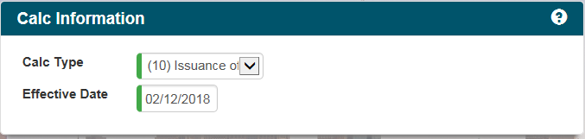
10. Click on the “Run Calc!” button.****
11. To ensure the actions are completed, go back to the applicant’s main page and check the “OTC” tile and “50058”tile. The “OTC” tile will be updated with the number of days remaining on the clock and the expiration date. The “50058” tile will contain the paper version of the Calc 10: